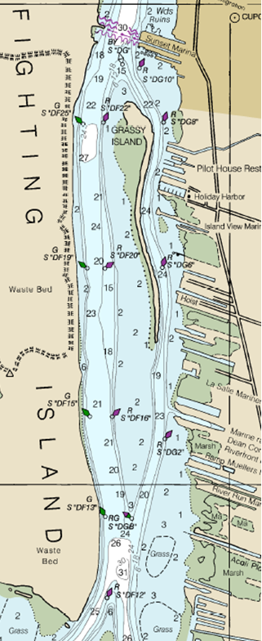
SCALE 100mm = 1nm

LaSalle Mariners Yacht Club

